PCI DSS and Payment Card Security Theoretical Course

Extracted from [here](https://www.youtube.com/watch?v=4xKFdU399vI)

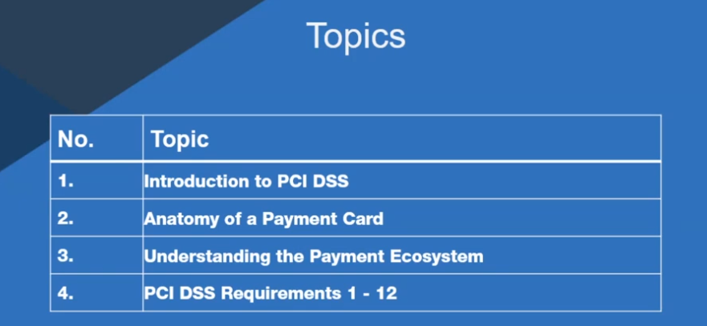

PCI has 300+ requirements

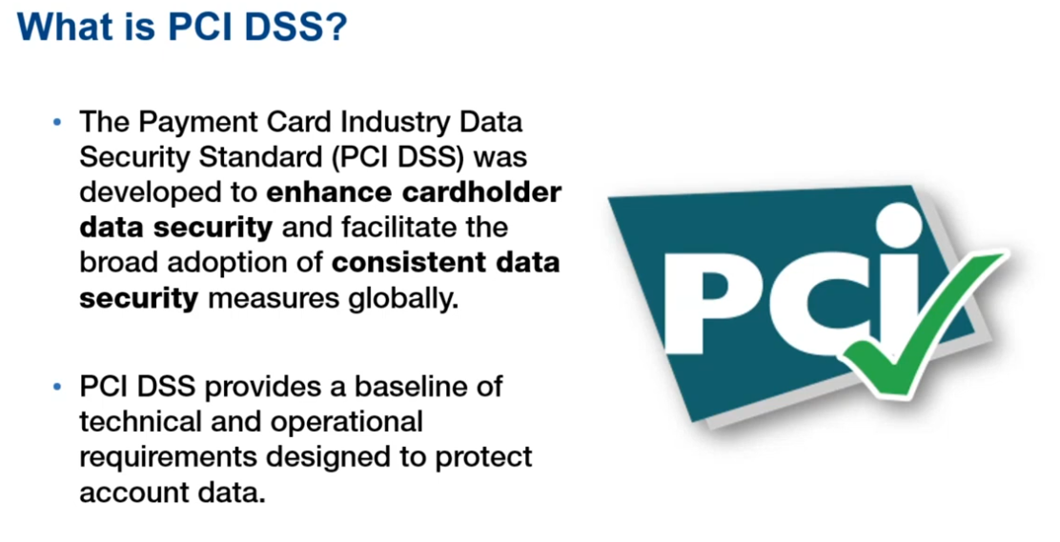

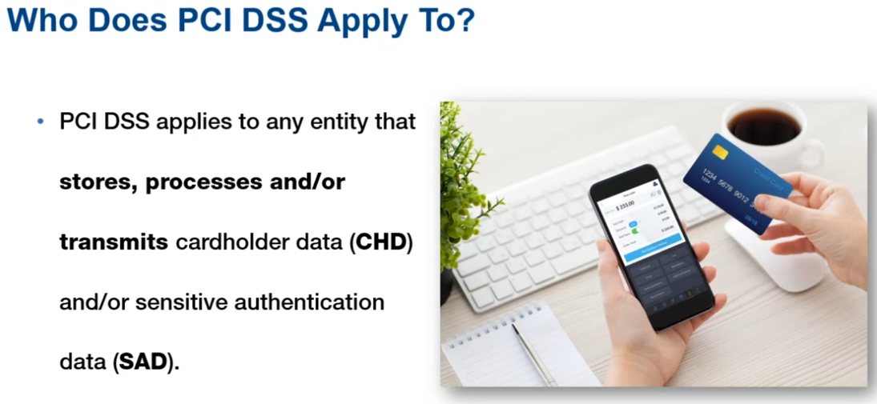

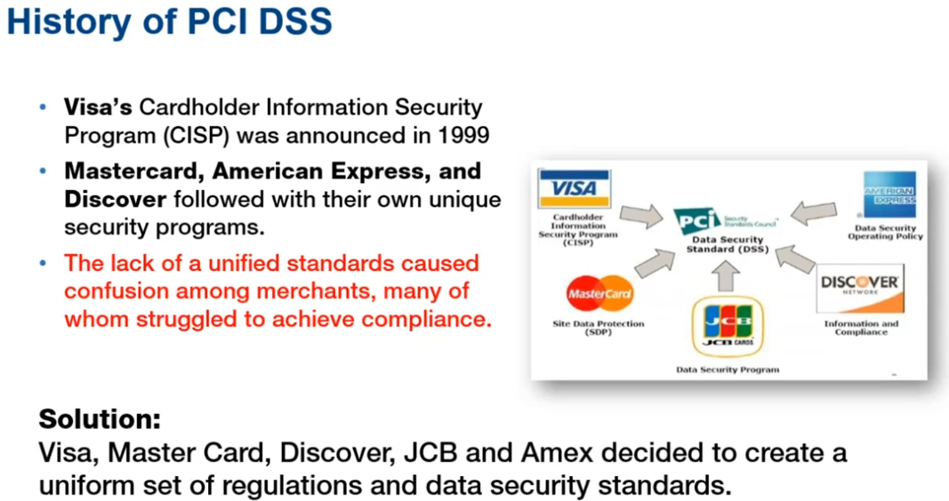

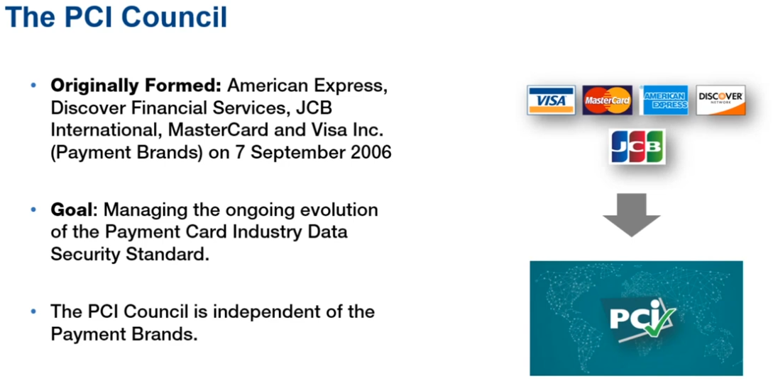

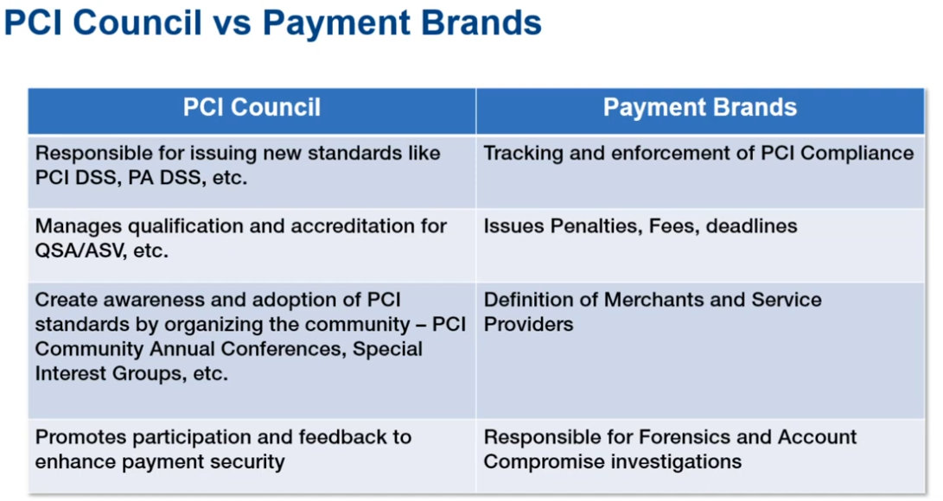

PCI council don’t enforce/audit standards on individual banks. QSA or PCI-QSA is a Qualified Security Assessor. He is auditor and issue certificates.

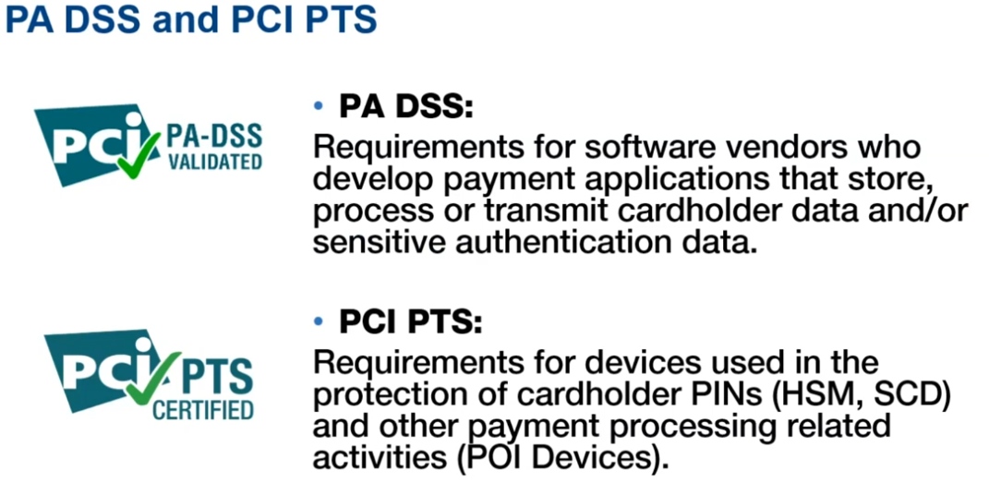

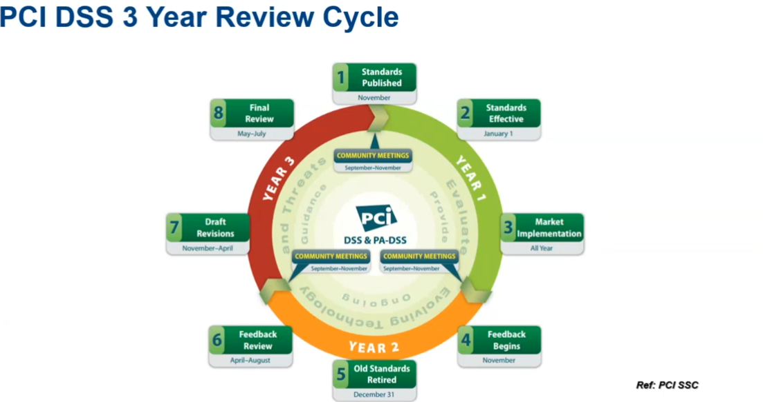

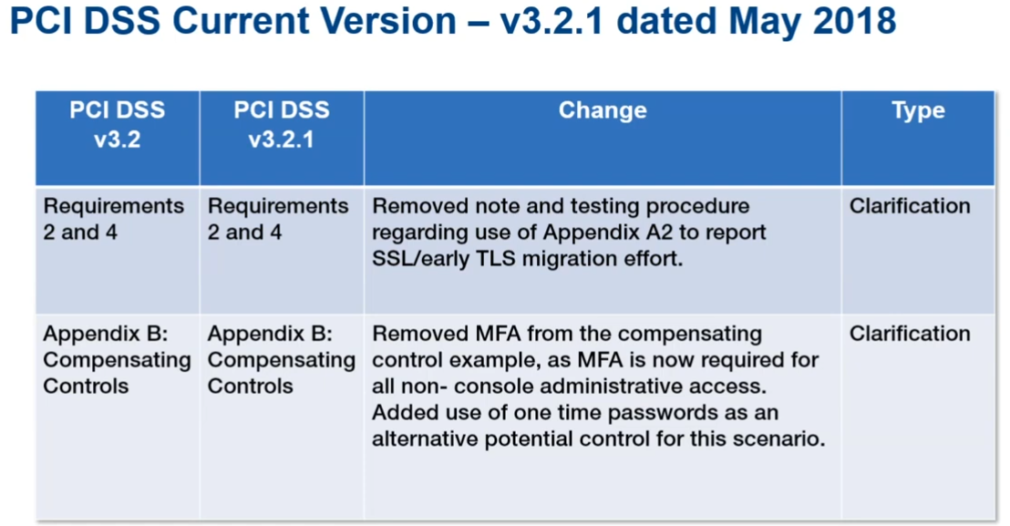

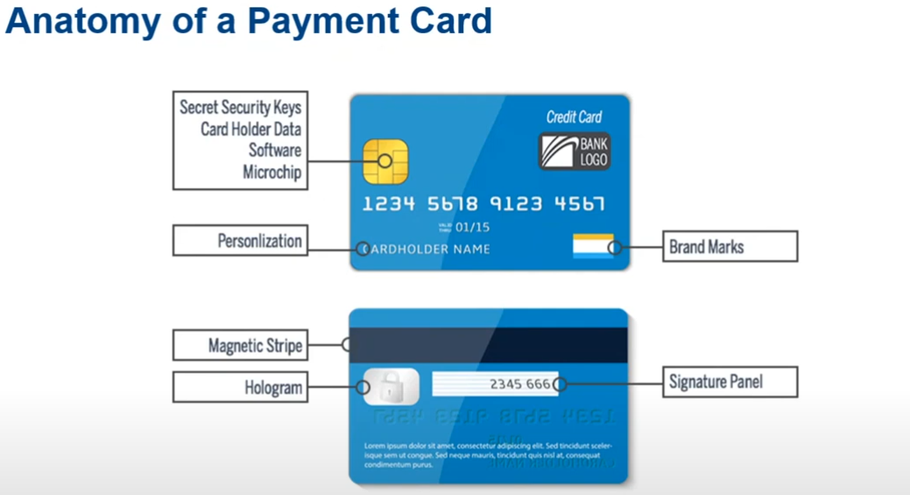

Any entity that process cardholder data, PCI applies to it.

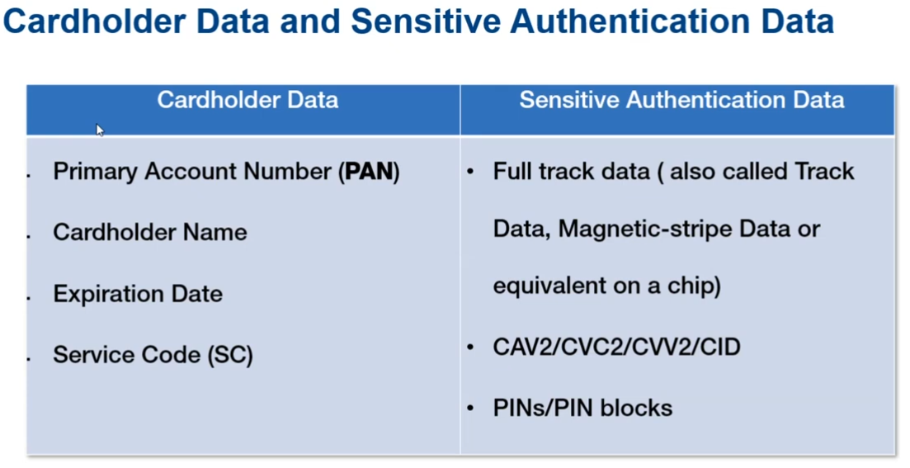

Service Code is embedded within magnetic stripe. Track data is used to identify bank, payment/card provider, pin.

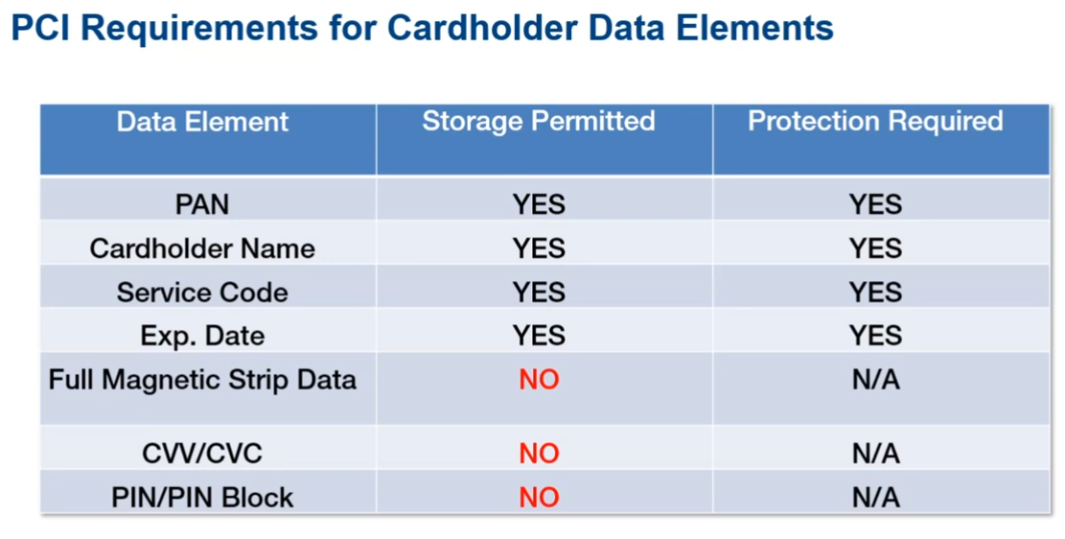

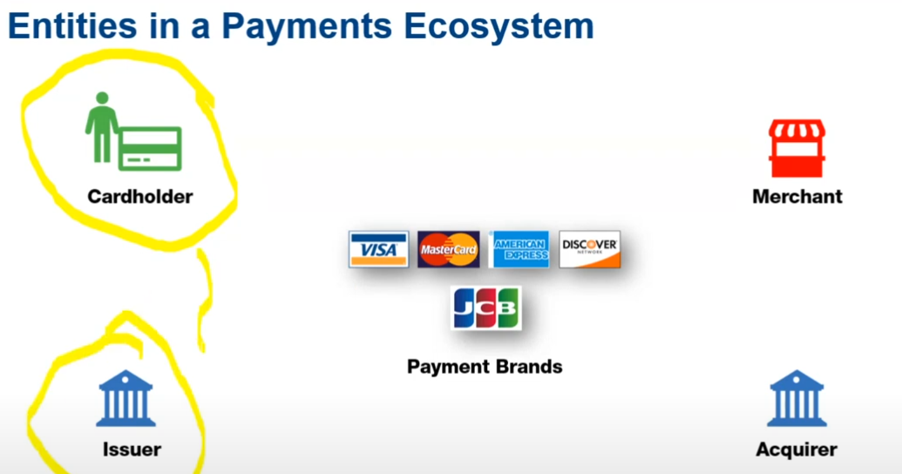

Issuer/Acquirer is the bank/financial institution. Merchants are ones who accept cards on their POS terminals (card readers) given to them by acquirer bank

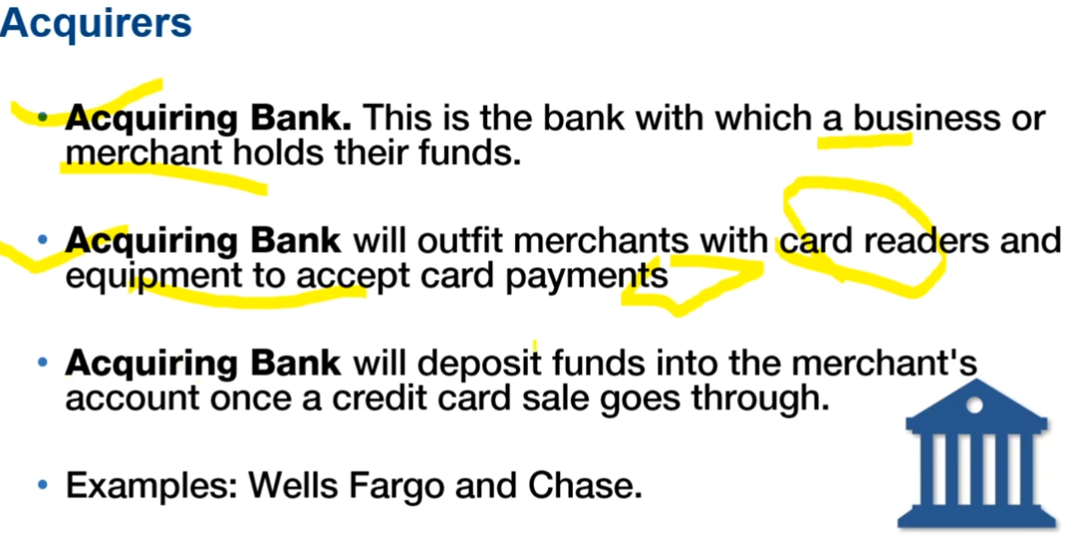

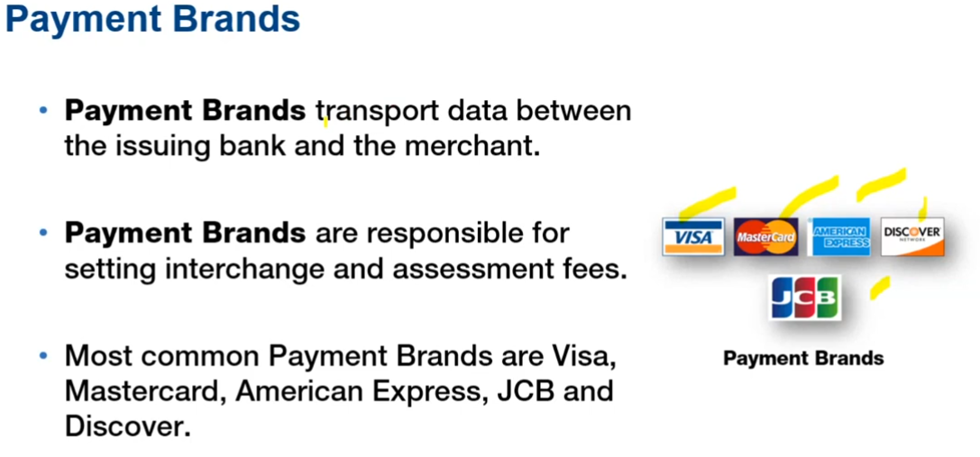

Payment brands main selling point is availability of network that banks use.

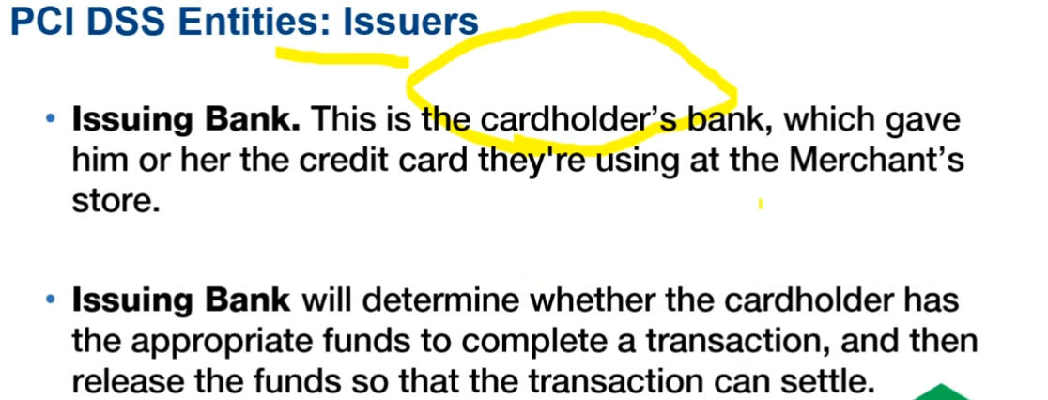

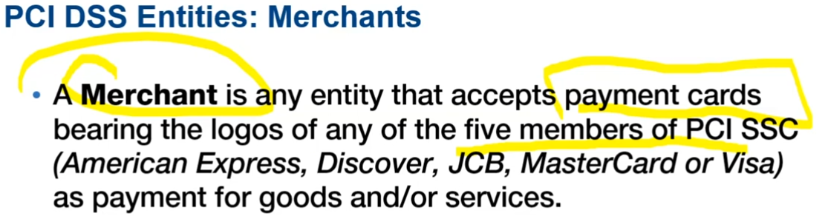

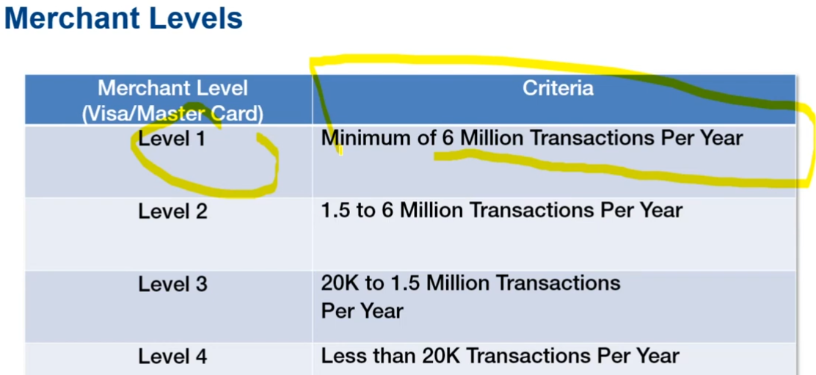

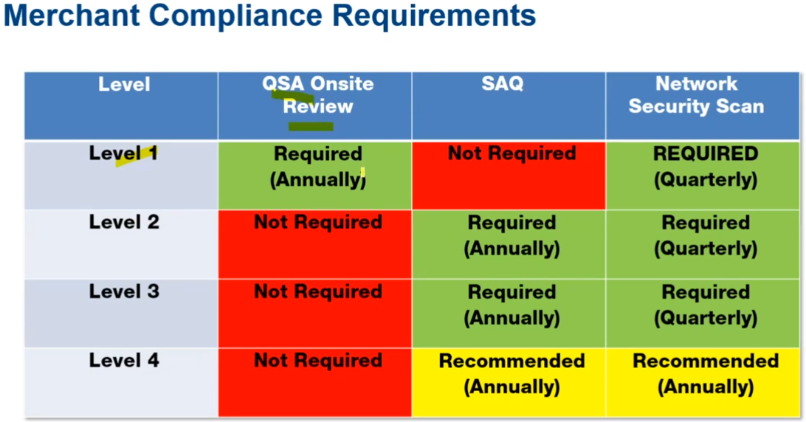

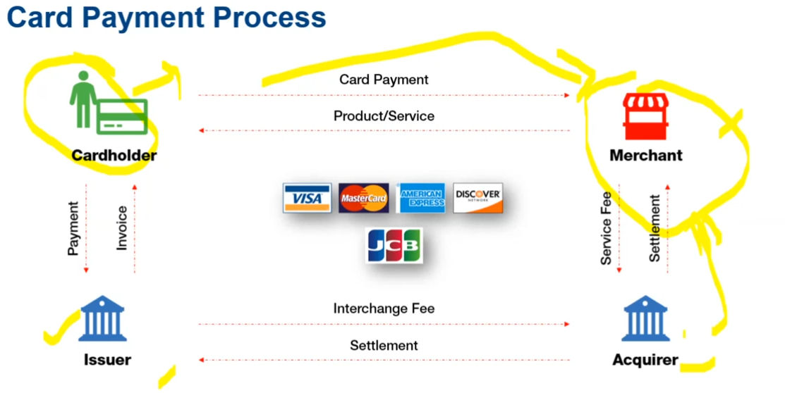

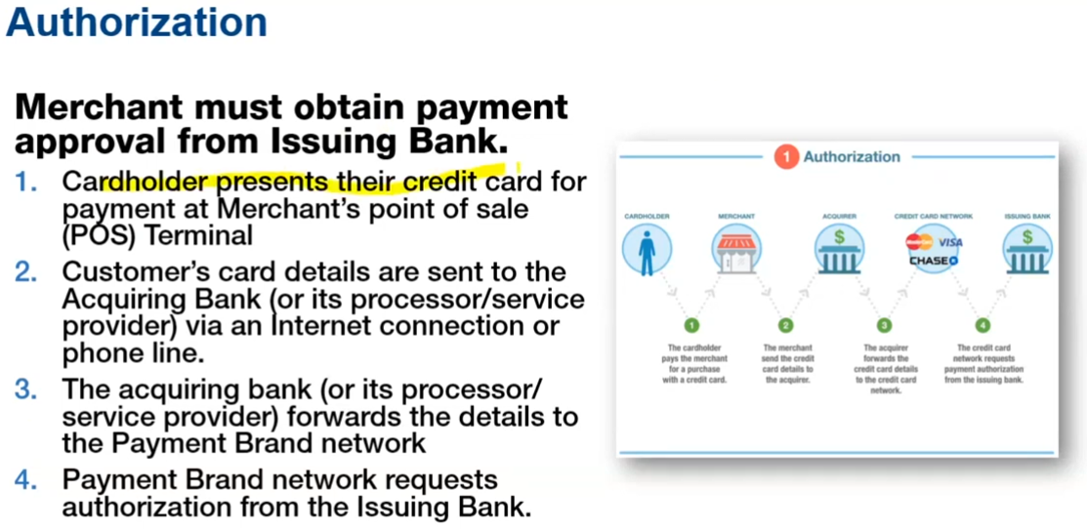

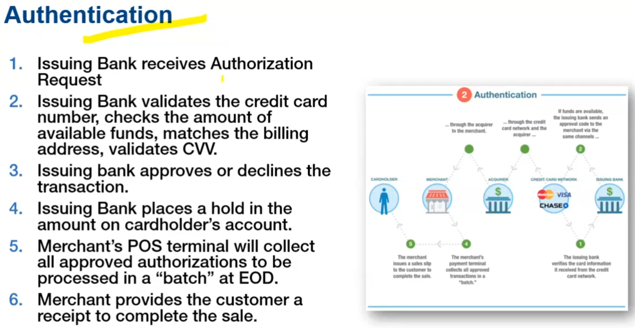

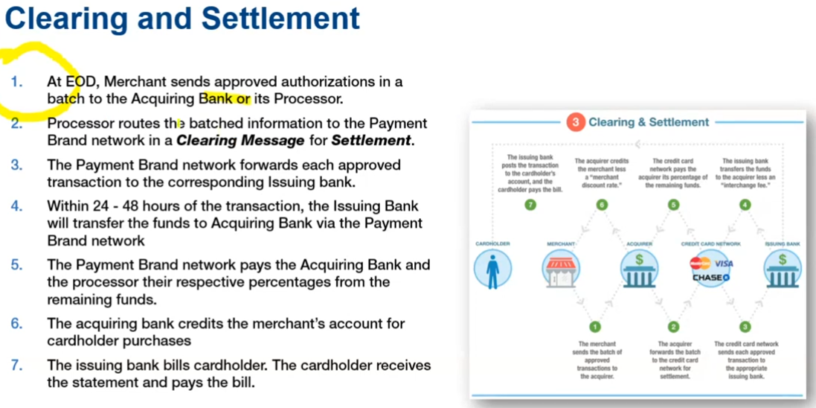

**Point-of-Sale (POS)** or online payment gateway

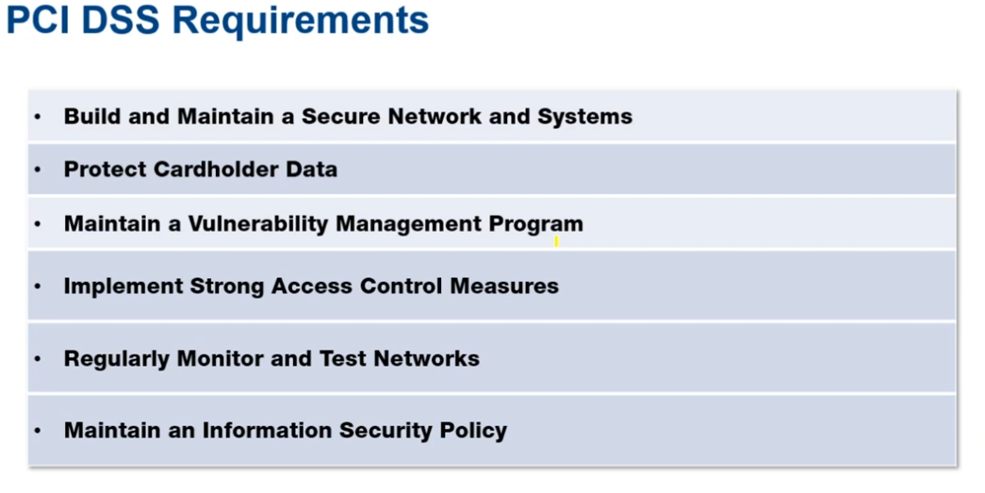

Requirements 1 and 2 falls under first category. Requirement 3 and 4 falls under second category. 5 and 6 under category three. Requirement 7 to 10 falls in category 4. Category 4 emphasizes on identity and access management. Requirement 11 is one category 5. Requirement 12 on category 6.

PCID goes very deep in technical aspect like it tells what antiviruses needs to be installed on what hardwares, what is the periodicity of antivirus scan, what are the privileges of end users

# Requirement 1: Install and maintain a firewall configuration to protect cardholder data

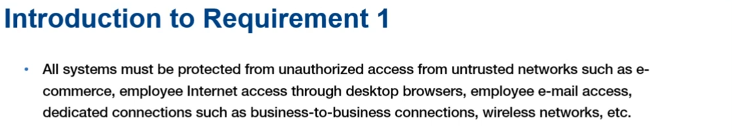

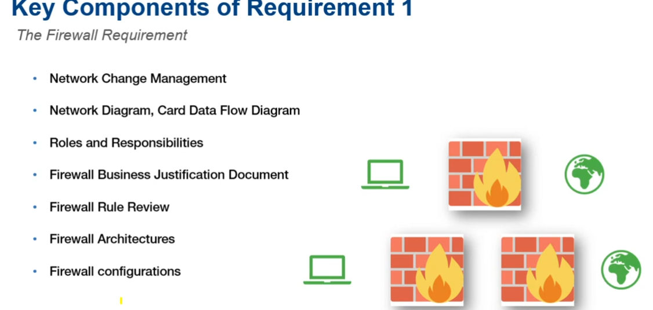

Network change management means properly assessing and approving a change. IT is to support business if a business has no specific need then that IT section/policy is not needed.

TEL-NET and FTP are ditched because they are not encrypted and transfer data in plain text.

# Requirement 2: Do not use vendor-supplied defaults for system passwords and other security parameters

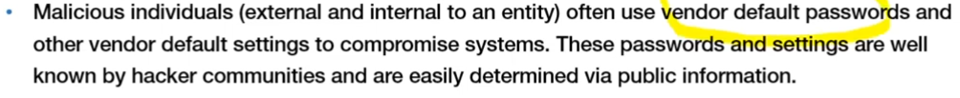

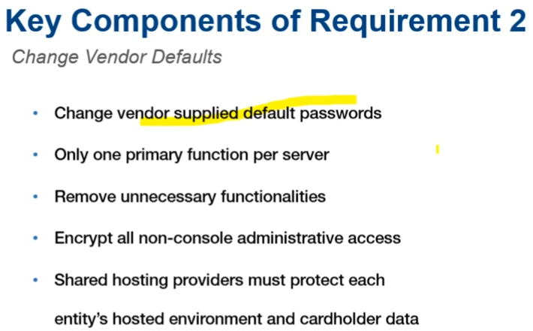

Only one function per server means restricting the functions to single server for security purposes; servers differ from each other like antivirus servers facing external world, log management server not connected to internet, active directory server no need to connect to internet. If an organization cannot afford different servers then their solution is to use virtual machines the purpose is to logically separate server.

# Requirement 3: Protect Stored Cardholder Data

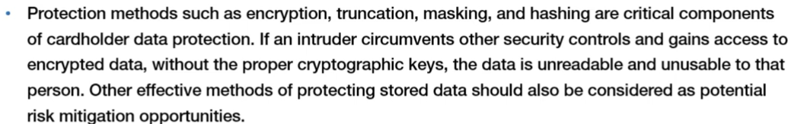

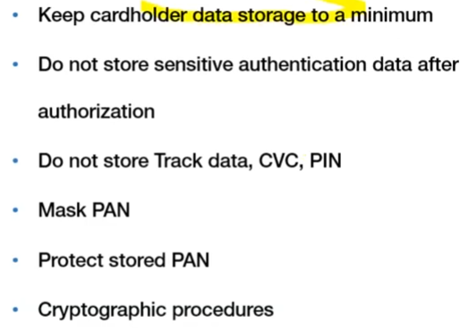

# Requirement 4: Encrypt transmission of cardholder data across open, public networks

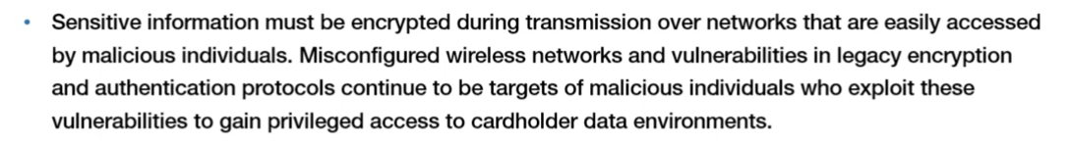

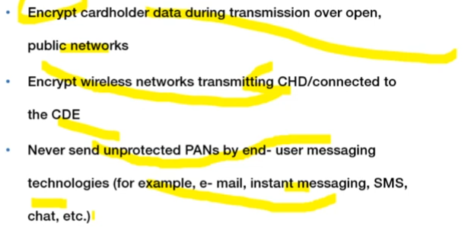

For an application following requirements are necessary 3, 4, and 6,7,8,10,11.

# Requirement 5: Protect all systems against malware and regularly update anti-virus software or programs

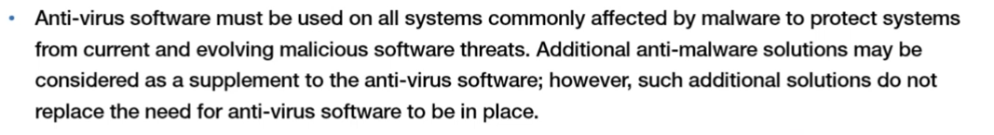

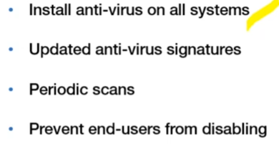

# Requirement 6: Develop and Maintain Secure Systems and Applications

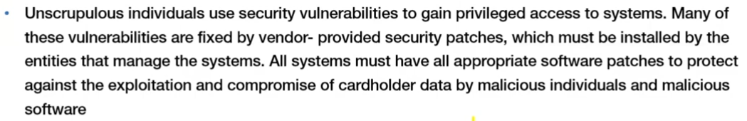

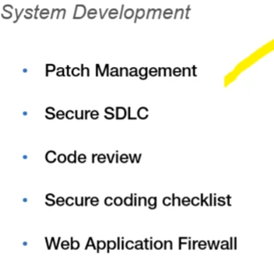

Secure SDLC requirement is difficult to meet because developers are mostly functionality oriented not security oriented. Security is after thought for them. PCI says security has to be a part of SDLC (either agile or waterfall etc.). Code review mechanism like peer review, lead review. OWASP top 10 or SANS top 10 will provide secure coding checklist. Either deploy a firewall or perform web app scans every 6 months.

# Requirement 7: Restrict access to cardholder data by business need to know

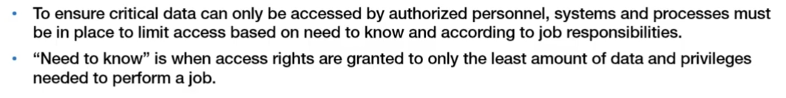

Simply if you really need then you will only get the cardholder data.

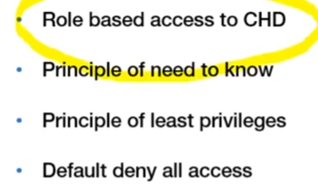

# Requirement 8: Identify and authenticate access to system components

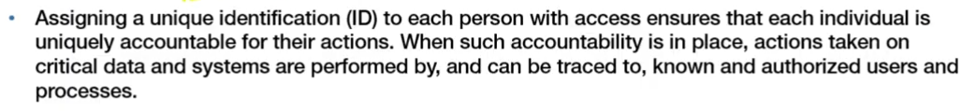

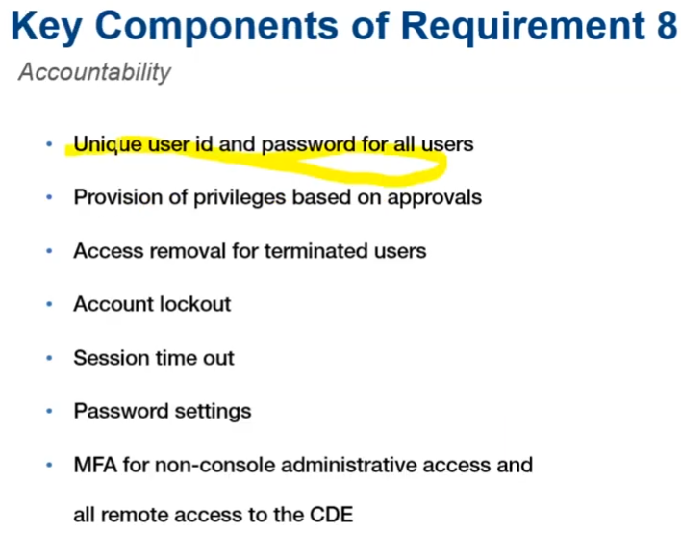

MFA is something you know, something you are, something you have at least 2 of them are invoked before access is provisioned.

# Requirement 9: Restrict physical access to cardholder data

Very difficult to get compliant with.

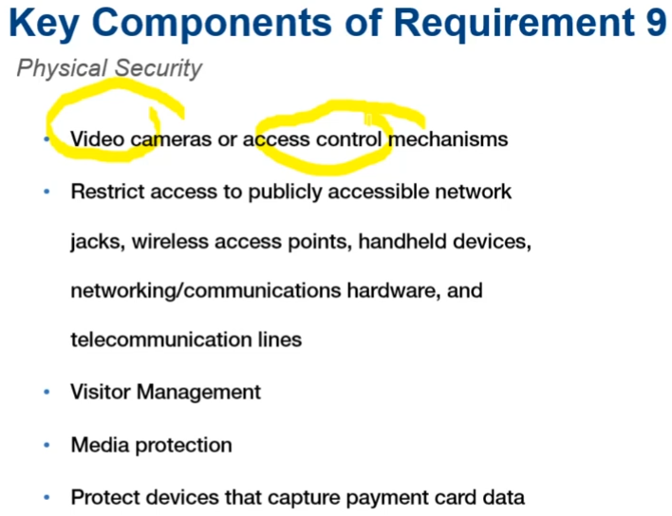

# Requirement 10: Track and monitor all access to network resources and cardholder data (VERY IMPORTANT)

We need to have logs for all components in system or cardholder data. Most difficult to apply with. Its implemented with SIEM (IBM QRadar, ATNT, ARCHside) in SOC. If an organization does not have in house SOC then it needs to use external services.

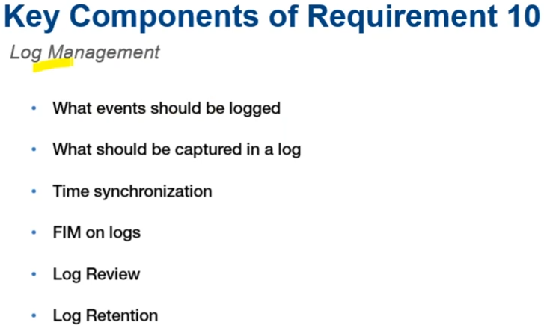

Some events like IP of devices involved, timestamp, outcome of activity (success or error). All servers should synchronize to one time server. FIM (File integrity monitoring) attackers will try to modify logs, FIM prevent or try to alert if logs are tried or modified. Log review means reviewing log every day and retention means storing logs for at least a year.

# Requirement 11: Regularly test security systems and processes

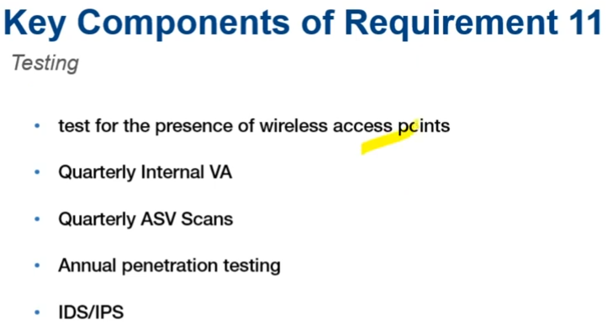

Rogue wireless access points could be setup. Multiple wifi related attacks like evil twin. VA fpr vulnerability assessment for internal IPs, for external devices use ASV (Approved Scanning Vendors) from PCI attested organizations.

# Requirement 12: Maintain a policy that addresses information security for all personnel

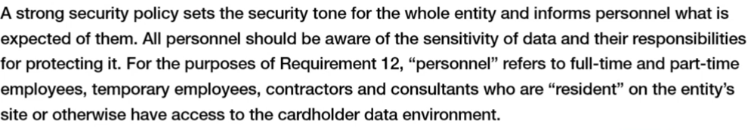

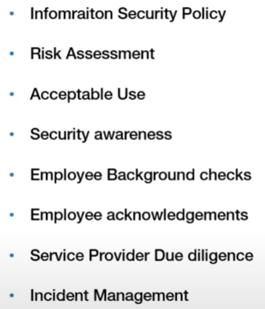

Risk assessment is in PCI/DSS since 2012, since then it has strongly focused on risk based compliance. PCI is not formally so heavy on documentation scope unlike ISO, PCI was more about technical implementations but now it values appropriate policies and practices and procedures intact.

ISO vs PCI: ISO is more of a holistic approach and open to interpretation, like you cannot comply still get certified, because you can exclude certain risks as they are not on our risk profile with proper reasoning. PCI is total black and white like you can be certify/compliant or not, it`s direct.

Payment Brands push compliance obligations on acquirers these acquirers in turn push compliance obligations on merchants.